ASSIGNMENT 8.1
Name : K.Uma Maheshwari
Batch : 44
2303A52430
Task 1 :{ Password Strength Validator – Apply AI insecurity Context)
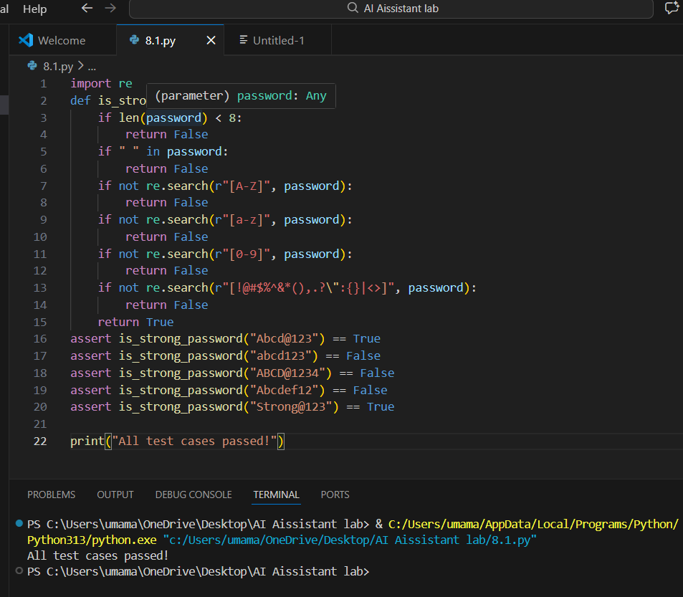

Task 2: Number Classification with Loops – Apply AI for Edge Case Handling
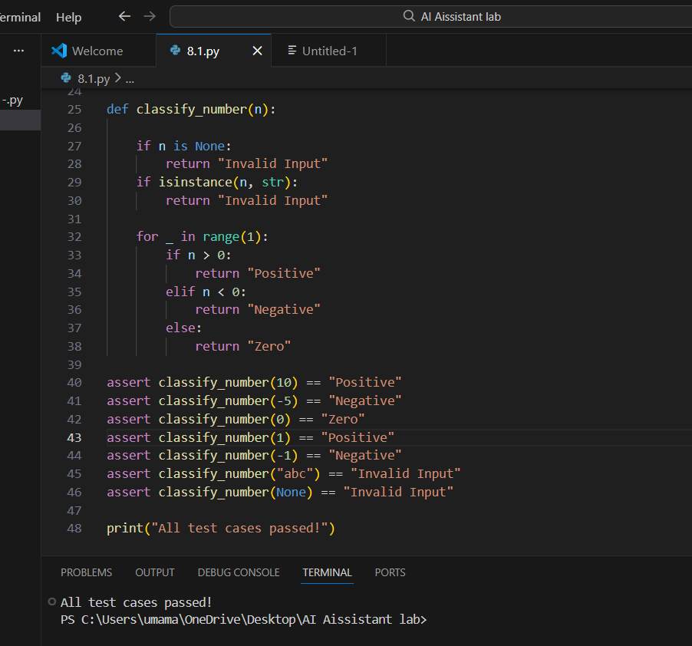

Task 3: Anagram Checker – Apply AI for String Analysis
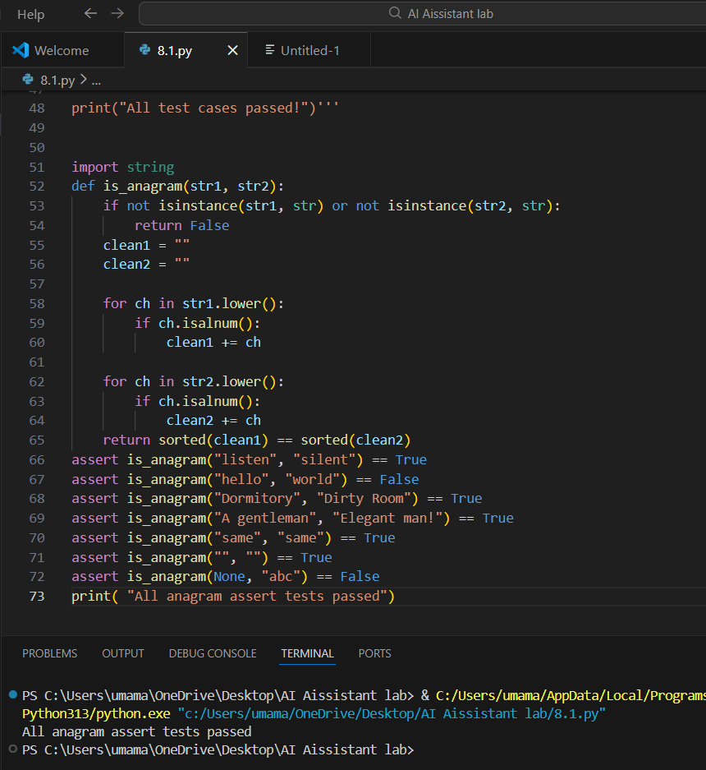

Task 4 : Inventory Class – Apply AI to Simulate Real- World Inventory System
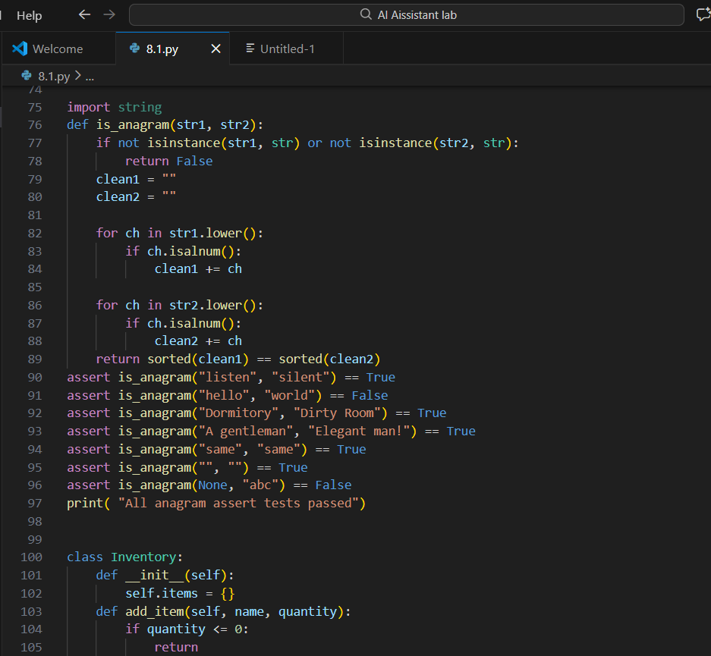
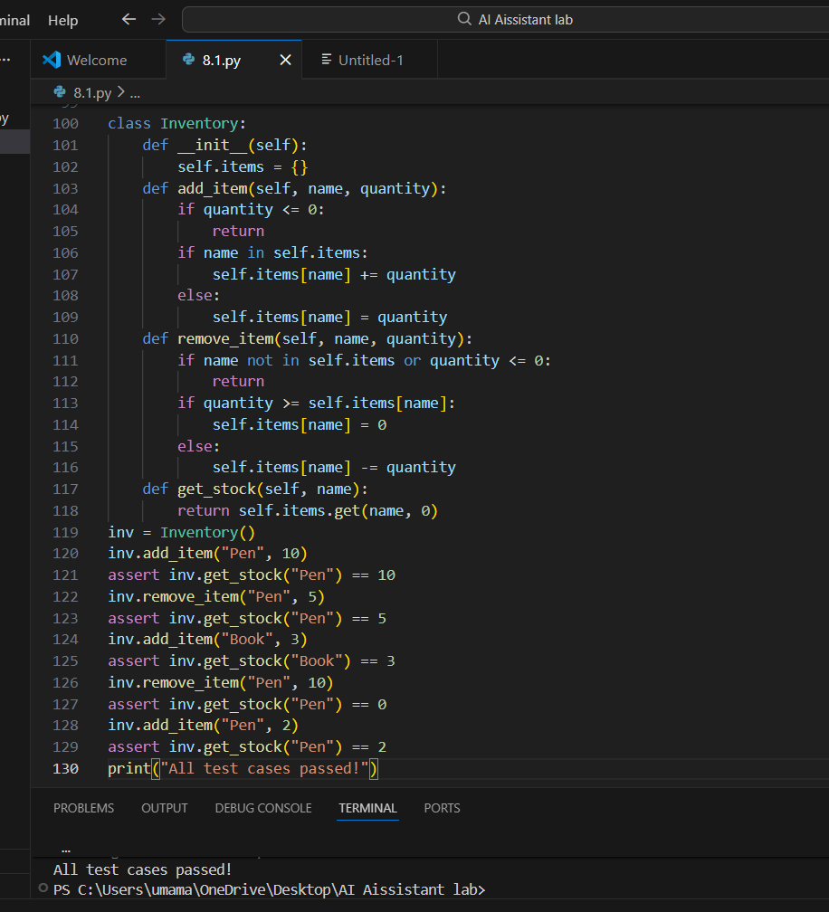

Task 5 : Date Validation & Formatting – Apply AI for Data Validation
